HM Prison and Probation Service (HMPPS)
Prison Supply Directorate
102 Petty France
LONDON
SW1H 9AJ

Telephone: 0300 047 6325
Email: AcceleratedHouseblocksDeliveryProgramme@ justice.gov.uk

13th August 2026

Dear Resident,

INVITATION TO RESIDENT EVENTS FOR HMP CHANNINGS WOOD EXPANSION PROJECT

I am writing to provide an update on the construction works taking place at HMP Channings Wood and to invite you to the next series of resident events. This is following the resident events we hosted in June 2025.

The construction work continues to progress well, and our constructors, Kier, are on track to complete the works and handover in late 2027.

We will be hosting two resident events in September 2026 to provide an update on the construction progress, to explain how the traffic management system has changed to better suit the community’s needs and give residents an opportunity to ask questions. We are hosting the same event on two separate days to give as many people as possible the chance to attend.

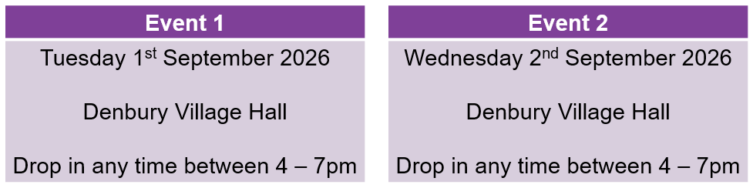

We are committed to working closely with local residents and community groups and we have dedicated team members available to listen to feedback, respond to concerns and for liaison throughout the construction period. We will continue to work with you to minimise the impact of the project on the neighbouring residents wherever possible.

We will provide you with further updates as the project progresses, but if you have any questions in the meantime or would like any further information, please contact us on our email address – AcceleratedHouseblocksDeliveryProgramme@justice.gov.uk.

Thank you for your continued support and co-operation.

Yours sincerely,



Sarah Carter
Acting Deputy Director, Prison Supply Directorate
Accelerated Houseblocks Delivery Programme
Ministry of Justice

